CSA0619-Design and Analysis of Algorithm
CO5-AT2
Permutation Generation with No Repetition
Aim:
To generate all possible permutations of a set of distinct elements using Backtracking, ensuring that no element is repeated within the same permutation.

Pseudocode:
ALGORITHM Generate Permutations(elements)
INPUT:
A set of n distinct elements
OUTPUT:
All possible permutations of the elements
BEGIN
n ← number of elements
visited[0...n-1] ← FALSE
permutation[0...n-1]
PROCEDURE Backtrack(position)
IF position = n THEN
PRINT permutation
RETURN
END IF
FOR i ← 0 TO n-1 DO
IF visited[i] = FALSE THEN
permutation[position] ← elements[i]
visited[i] ← TRUE
Backtrack(position + 1)
visited[i] ← FALSE
permutation[position] ← EMPTY
END IF
END FOR
END PROCEDURE
Backtrack(0)
END
Source Code:
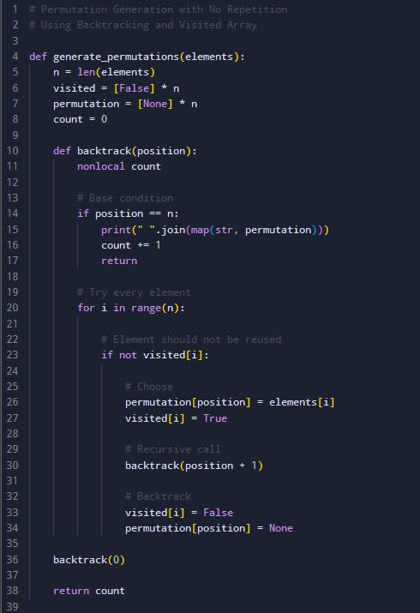

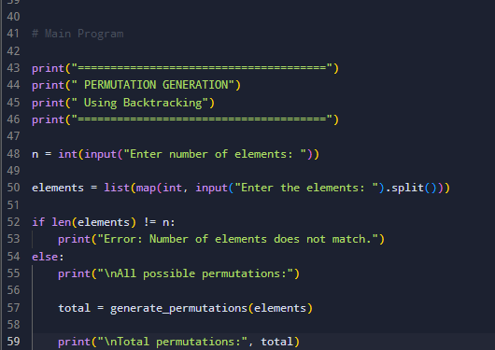

Output:
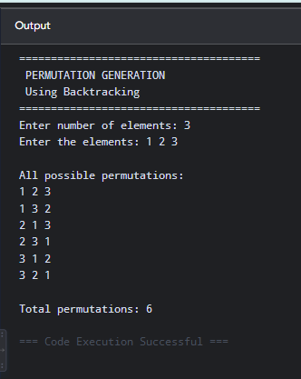\
Time Complexity: O (n × n!)
Space Complexity: O(n)

